DIS-EUR-Bulgaria-Neolithic- Flat Bone Figurine

## 

Fig. 1 Bulgarian Neolithic, Flat Bone Figurine, ca 5th millennium BCE,

Formal Label: Bulgarian Neolithic, Flat Bone Figurine, ca 5th millennium BCE

Accession Number: GN778.22.B9.A1

Date or Time Horizon: 5th millennium BCE

Geographical Area: Bulgaria

Cultural Affiliation: Neolithic

Media: Bone

Dimensions: 77 mm: high

Weight:

Provenance: Provenance: Italian Private Collection; then Martin Dimov, Mladost 2, 239/3/3/88 1799 Sofia, Sofia, Bulgaria

This Flat Bone Figurine from Bulgaria is a product of the Neolithic period of the South-East Europe, a period of economic and social change, which was based on earlier cultivation and herding practices in Anatolia during the **Pre-Pottery Neolithic** Period (**PPN**, around 8500-5500 BCE). In South-East Europe intensive garden agriculture was integrated with small-scale herding prior to the emergence of crop agriculture and caprine husbandry during the **Pre-Pottery Neolithic** B culture. Integration of small-scale cultivation and herding during the PPNB facilitated the spread of agriculture in South-East Europe and this advance provided the expendable time and energy to craft prestige objects such as these Flat Bone Figurines (cf. Evans 1978; Manolakakis and Averbouh 2004: 155, see also Renfrew 1988; Manolakakis 1996).

The function and semantics of Flat Bone Figurines were reflected in the use of them as personal amulets as most were probably used as personal amulets and their highly schematized female bodies provided a philosophical interconnection between the fertility of the land and that of the female human population. Their highly abstract representation of the female human fertility attributes suggests that they were meant to signify the importance of fertility in general terms and in ways in which human and earthly fertility attributes were interconnected and had an impact on the individuals who used these as amulets.

Flat Bone Figurines were crafted in local communities probably of caprid bone and they were modeled according to an artistic grammar, which was grounded in a long-standing Neolithic tradition which had diffused to the Balkans from southwestern Anatolia through the Cyclades to the Greek Peloponnesian mainland where they were associated with painted pottery. And this is where there is a sharp distinction between the Balkans and Western Europe, since in Western Europe figurines are completely absent from contexts of painted ceramics. (Hansen 2007). This suggests that if women crafted the figurines they may have been also responsible for crafting ceramics. Therefore, the emergence of new ideas reflecting agriculture and community development were accomplished by women who embodied these ideas in this Neolithic type of flat bone figurine (see also Hansen 2011).

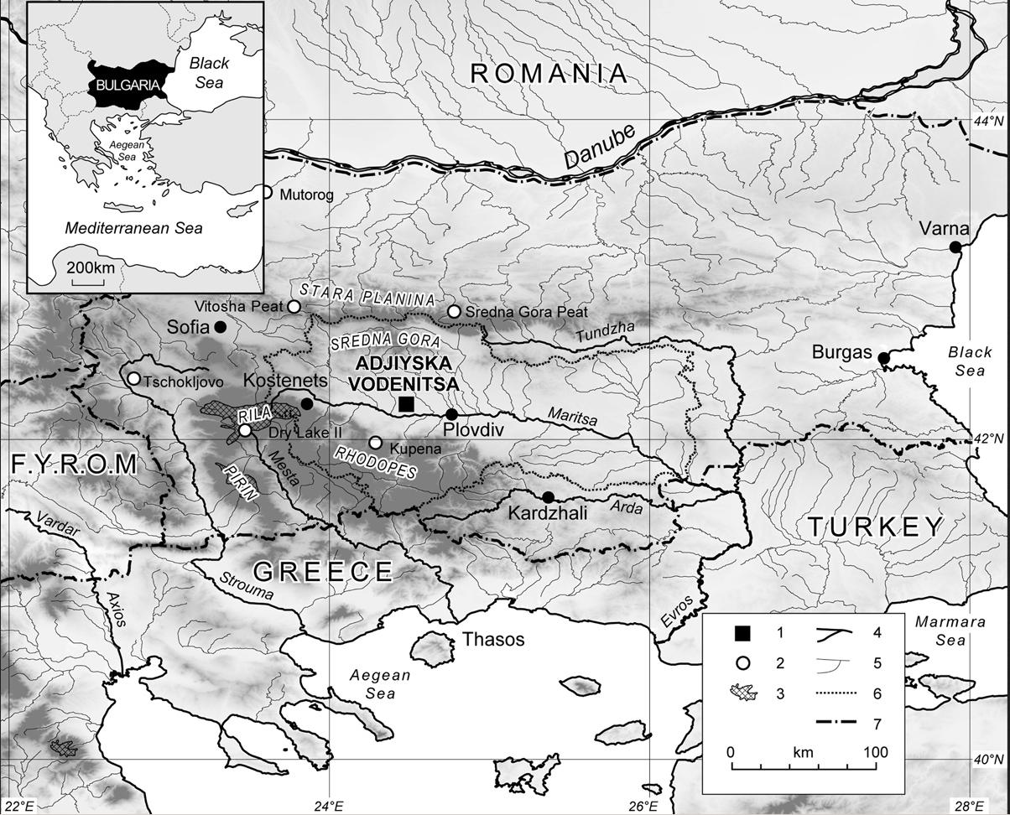

https://geomorphologie.revues.org/docannexe/image/7747/img-1.jpg

# BEGIN to edit

For instance, osseous raw material (bone, antler, teeth) and even mollusk shells had used throughout

prehistory for utilitarian tools, decorative items, auxiliary artifacts

and parts of composite objects, and even pieces of arts. Most of the Paleolithic

portable figural art (plaques with reliefs or figurines) is, in fact, made from bone, antler

or mammoth ivory (e. g., Hahn 1972; Barandiárn 1994). However, the cultural attitude

towards certain raw materials changed significantly in diverse societies, so, for

example, central Balkan Neolithic societies (both Starčevo and Vinča cultures) have

extremely rich figural art, but made almost exclusively from clay, with only few rare

examples in stone (cf. Срејовић 1968; Тасић 2008; Игњатовић 2008).

The high symbolic value and probably also prestigious character of the flat bone figurines

is suggested by the necropolis at Varna, on the Black Sea coast, which, apart from

extraordinary finds in gold and other “luxurious” raw materials, also yielded several

bone figurines, some of them of considerable dimensions, and completely unused,

i. e., made exclusively for funeral (Manolakakis and Averbouh 2004). Figurines are

also seen as “ideological innovation” of the Early Eneolithic (Hansen 2011).

The bone figurines belong to the group of the artefacts that are considered as

“index fossils” (“fossiles directeurs”), i. e., chronologically sensitive type of objects

for the Eastern Balkan Chalcolithic (cf. Георгиева 2014: 225; Averbouh and Zidarov

2014: 183). They are known from present-day Romania and Bulgaria and were

discovered within Kodjadermen-Gumelniţa-Karanovo VI and Bubanj-Salcuţa-

Krivodol cultural complexes. They appear since Gumelniţa A1 phase, although are

most common in phases A2 and B1, and also seem to be more common in earlier

phases of the BSK cultural complex (see, for example, finds from Salcuţa, belonging

to phase Salcuţa I – Berciu 1961, fig. 157/2, or in Devetashka peshtera – Георгиева

2012: 244–245; cf. also Comşa 1976; Andreescu 2002: 55–67).

So far, over 80 sites with one or more figurines were identified (Fig. 1), in eastern

Romania and eastern Bulgaria (cf. Comşa 1979; Andreescu 2002; Петков 1950;

Averbouh and Zidarov 2014, with references). To the extensive list provided by A.

Averbouh and P. Zidarov (2014) may be also added Kozareva Mogila in Bulgaria

(Георгиева 2014) and Cuptoare in Romanian Banat (Radu 2002: Pl. 100/4).

The most interesting finds come from Hotnica in Bulgaria (Ангелов 1961),

where several figurines in different stages of manufacture were discovered within

one dwelling, suggesting a workshop or working place, and from necropolis in Varna,

where a large number of graves contained completely new, unused figurines –

a total number of 28 figurines were discovered: twenty-three were vaulted, violin-

shaped figurines, 4 flat and one fragmented, undetermined (Manolakakis and

Averbouh 2004: 159).

The figurines are characterized by strict choice of raw materials, uniform morphology

and decorative designs (Averbouh and Zidarov 2014: 183). After the conceptual

framework of *manufacturing continuum,* designed by A. Choyke (1997,

2001), the figurines fall into class of artefacts that were highly valued, with large labour,

time and skill investment, that gave and/or increased their prestigious status.

Typological classification has been offered by several authors, with minor variations

(cf. Петков 1950: 25–26, with references). Three main types may be outlined:

1) schematized vaulted figurines with apendice, also called violin-shaped,

usually of considerable dimensions, 2) medium-sized flat figurines and 3) figurines made from short bones by minimal alterations to their natural shape, mainly limited to perforations and grinding of surfaces (cf. Todorova and Vajsov 2001; Andreescu

2002: 55–67; Manolakakis and Averbouh 2004; Averbouh and Zidarov 2014).

Sometimes, these figurines had elements made from other material, mainly copper

(Todorova and Vajsov 2001), but also from serpentinite (Георгиева 2014).

Flat figurines usually have three-partite division – head, that may be triangular,

oval or hexagonal, torso, usually decorated, and legs, that may be only schematized,

joint or very elaborated and separated (cf. Петков 1950; Comşa 1979; Andreescu

2002: 55–67). The decoration also shows variations, they may have dotted, linear or

no ornamentation at all, and these differences may be of regional character (Averbouh

and Zidarov 2014).

Flat figurines are much better presented at settlement sites, in fact, only four came

from funeral context, from necropolis at Varna (Manolakakis and Averbouh 2004). It

is interesting to note that at Pietrele in Romania all the figurines were discovered within

houses, not a single one came from an open area (Hansen 2011: 120).

As already mentioned, figurines had high symbolic and probably prestigious

character, and it was suggested they were used as personal items, perhaps even attached

to clothes (Тодорова 1980). Intensive traces of use visible on almost all of

them confirm such hypothesis (Averbouh and

Zidarov 2014: 191).

## 

Fig. 1 Sites with flat bone figurines (after: Averbouh and Zidarov 2014; Radu 2002; Andreescu 2002)

-Sites with one or more figurines of that type

-Sites with unfinished or undecorated figurine

-Dense concentration of sites with flat bone figurines on a small area

## Salkuta -Sites of BSK complex with this type of figurines

REFERENCES

**Andreescu, R. R. 2002**

*Plastica antropomorfă Gumelniţeană*, Bucureşti: Muzeul Naţional de istorie a Romăniei.

**Ангелов Н. 1961**

Работилница за плоски костени идоли в селищната могила при с. Хотница, Тьр-

новско, *Археология* 3 (2): 34–38.

**Averbouh, A. and Zidarov, P. 2014**

The production of bone figurines in the Balkan Chalcolithic and the use of debitage by

extraction, in: *An overview of the exploitation of hard animal materials during the Neolithic*

*and Chalcolithic*, M. Mărgarit, G. Le Dosseur and A. Averbouh, eds.,Tărgovişte:

Editura Cetatea de Scaun, 183–200.

**Barandiárn, I. 1994.**

Arte mueble de paleol咜ico cant畸rico: una visi de s匤tesis en 1994, *Complutum* 5:

45–79.

Berciu, D. 1961

*Contribuţii la problemele neoliticului in Rominia in lumina noilor cercet穩i*, Bucureşti:

Editura Academiei Republicii Populare Romîne.

Bulatović, A. and Milanović, D. 2012

Preliminarni rezultati arheoloških iskopavanja na lokalitetu Bubanj u Novom Selu u

2011. godini, in: *Arheologija u Srbiji, projekti Arheološkog instituta u 2011. godini*, V.

Bikić, S. Golubović i D. Antonović, eds., Beograd: Arheološki institut, 22–25.

Bulatović, A., Milanović, D. and Vitezović, S. 2014

Preliminarni rezultati istraživanja lokaliteta Bubanj u 2013. godini, in: *Arheologija u*

*Srbiji, projekti Arheološkog instituta u 2013. godini*, D. Antonović, S. Golubović i V.

Bikić, eds., Beograd: Arheološki institut, 22–25.

Choyke, A. 1997

The bone tool manufacturing continuum, *Anthropozoologica* 25–26: 65–72.

Choyke, A. 2001

A quantitative approach to the concept of quality in prehistoric bone manufacturing,

in: *Animals and man in the past. Essays in honour of Dr. A.T. Clason, emeritus professor*

*of archaeozoology Rijksuniversiteit Groningen, the Netherlands*, H. Buitenhuis and W.

Prummel, eds., Groningen: ARC-Publicatie 41, 59–66.

Comşa, E. 1976

Date despre un tip de figurină neolitică de os, *Studii şi cercetari de istorie veche* 27 (4):

557–564.

Comşa, E. 1979

Les figurines en os appartenant à la phase moyenne de la culture Gumelniţa, *Dacia*

(n.s.) 23: 69–78

d’Errico, F. 1993

Identification des traces de manipulation, suspension, polissage sur l’art mobilier en

os, bois de cervids, ivoire, in: *Traces et fonctions: les gestes retrouvée,* vols 1-2, P. C.

Anderson, S. Beyries, M. Otte and H. Plisson, eds., ERAUL 50, Li鑒e: Centre de Recherches

Archéologiques du CNRS, Études er Recherches Archéologiques de l’Université

de Lille, 177–188.

Evans, R. K. 1978

Early craft specialization: An example from the Balkan Chalcolithic, in: *Social*

*archaeology: beyond subsistence and dating*, C. L. Redman, M. J. Berman, E. V. Curtin

et al., eds., New York: Academic press, 113–129.

Ганецовски, Г. 2003

Керамика от късноенеолитното селище Багачина край Сталийска махала, Мон-

танско, *Известия на музеите в Северозападна Блгария* 29: 13–50.

Garašanin, M. 1958a

Neolithikum und Bronzezeit in Serbien und Makedonien, *Bericht der Risch-Germanischen*

*Kommission des Deutschen Arch與logischen Instituts* 39: 1–130.

Garašanin, M. 1958b

Kontrollgrabung in Bubanj bei Niš, *Praehistorische Zeitschrift* 36: 223–244.

Гарашанин, М. 1960

Бубањ код Ниша, *Старинар* (н.с.) 11: 235–237.

Гарашанин, М. and Ђурић Н. 1983

*Бубањ и Велика хумска чука*, Ниш: Народни музеј.

Гарашанин, M. аnd Симоска, Д. 1976

Контролни ископувања на Шуплевец и некои проблеми на групата Шуплевец-

Бакарно гумно, *Macedoniae Acta Archaeologica* 2: 9–41.

Георгиева, П. 2012

*Керамиката на култура Криводол-Сълкуца*, София: Универзитетско издател-

ство „Св. Климент Охридски“.

Георгиева, П. 2014

Костени антропоморфни фигурки от Козарева могила, in: *In memoriam Lilyana*

*Pernicheva-Perets*, В. Петрова, С. Танева and К. Бояджиев, eds., Годишник на на-

ционалния археологически музей 12, София: Българска академия на науките,

Национален aрхеологически институт с музей: 225–232.

Hahn, J. 1972.

Aurignacian Signs, Pendants and Art Objects in Central and Eastern Europe, *World*

*Archaeology* 3 (3): 252–266.

Hansen, S. 2011

Figurines in Pietrele: Copper Age Ideology, *Documenta Praehistorica* 38: 117–129.

Игњатовић, М. 2008

Каталог, in*: Винча, праисторијска метропола,* Д. Николић, ed., Београд: Фило-

зофски факултет, Народни музеј, Музеј града Београда, Српска академија наука

и уметности, 203–277.

Lemonnier, P. 1992

*Elements for and anthropology of technology,* Michigan: Ann Arbor.

Lyman, R. L. 1994

*Vertebrate taphonomy,* Cambridge: Cambridge University Press.

Manolakakis, L. and Averbouh, A. 2004

Grandes lames et grandes statuettes, marqueurs de l’activité funéaire dans le Chalcolithique

de Bulgarie, in: *XXVe Congrés Préhistorique de France, Nanterre 24–26 novembre*

*2000 – Approches fonctionnelles en Préhistoire,* Nannterre: Société préhistorique

française, 155–165.

Manolakakis, L. 1996

Production lithique et émergence de la hiéarchie sociale: l’industrie lithique de l’Enéolithique

en Bulgarie (Premiére moitié du IVe milléaire), *Bulletin de la Société préhistorique*

*française* 93 (1): 119–123.

Миков, В. and Джамбазов, Н. 1960

*Деветашката пещера*, София: Българската академия на науките.

Newcomer, M. 1974

Study and replication of bone tools from Ksar Akil (Lebanon), *World Archaeology* 6/2:

138–153

Orssich de Slavetich, A. 1940

*Bubanj, eine Pr臧istorische Ansiedlung bei Niš*, Wien: Mitteilungen der pr臧ist.

Kommission der Akademie Wissenchaften.

Peltier, A. 1986

ﾉtude exp駻imentale des surfaces osseuses fa輟nn馥s et utilis馥s, *Bulletin de la Soci騁é*

*Pr馼istorique Fran軋ise* 83/1: 5–7.

Петков, Н. 1950

Класификация на плоските костни идоли в Балкано-дунавската област, *Годи-*

*шник на народния музей Пловдив* 2: 25–37.

Попов, Н. 1992

Антропоморфни костени фигурки от селищната могила край г. Смядово, *Годи-*

*шник на музеите от Северна България* 18: 17–43.

Radu, A. 2002

*Cultura Sălcuța ăn Banat,* Reșița: Editura Banatica.

Renfrew, C. 1986

Varna and the emergence of wealth in prehistoric Europe, in: *The Social Life of Things:*

*Commodities in Cultural Perspective*, A. Appadurai, ed., Cambridge: Cambridge University

Press, 141–168.

Roman, P. 1971

Strukturannderungen Des End Aneolithikums im Donau-Karpaten-Raum, *Dacia*

(n.s.) 15: 31–169.

Симоска, Д., Китаноски, Б. and Тодоровић, Ј. 1976

Населбата Црнобуки и проблемот на истоимената култура во светлината на но-

вите археолошки истражувања, *Macedoniae Acta Archaeologica* 2: 43–84.

Срејовић, Д. 1968

Неолитска пластика централнобалканског подручја, in: *Неолит централног*

*Балкана*, Л. Трифуновић, ed., Београд: Народни музеј, 177–241.

Тасић, Н. Н. 2008

Неми сведоци једног времена: фигурална уметност Винче, in*: Винча, праисто-*

*ријска метропола,* Д. Николић, ed., Београд: Филозофски факултет, Народни

музеј, Музеј града Београда, Српска академија наука и уметности, 139–163.

Тодорова, Х. 1980

Классификация и числовой код пластики неолита, энеолита и ранней бронзо-

вой эпохи Болгарии, *Studia praehistorica* 3: 43–64.

**Todorova, H. and Vajsov, I. 2001**

*Der kupferzeitliche Schmuck Bulgariens,* Pr臧istoriche Bronzefunde 20 (6), Stuttgarrt:

Franz Steiner Verlag Wiesbaden GmbH.

**Трајковић-Филиповић, Т., Милановић, Д. and Булатовић, А. 2009**

Ревизиона археолошка ископавања археолошког локалитета Бубањ код Ниша у

2008. години, *Зборник – Народни музеј* (Ниш) 16–17: 309–318.